**Ruan Zwarts, Christian Versfeld, Mohammed Bhula, Phuti Motimele**

**Student Number: ST10158660, ST10091991, ST10073908, ST10191686**

**Pathway: IPMA6212 Assignment 2**

**Lecturer: Dasram Sundesh**

**8th May 2024**

**IMPA6212 Assignment 2**

Table of Contents

1. **Question 1:**
2. **Question 2:**
3. **Question 3:**
4. **Question 4:**
5. **Question 5:**
6. **Reference List:**

## Question 1.1:

The Crime Report application was developed in response to the community's widespread issue of underreporting crimes and delayed reactions to criminal situations. Many citizens are afraid to report crimes for fear of retaliation, discrimination or a lack of confidentiality. There is also a breakdown in fast communication between communities and local law enforcement, which results in longer response times. This application intends to give citizens a safe, anonymous, and efficient means to report crimes directly from their cellphones, raising crime reporting rates and reducing local authorities' reaction times. This will hopefully mitigate the amount of crimes and also keep more people safe from discrimination, fear of retaliation and in the possible worst case scenario death(she/her, H.F. et al., no date).

## Question 1.2:

Technological Trend: Cross-Platform Mobile Application Development

What is the current technical trend?

Cross-platform development allows you to create mobile applications that run on multiple mobile operating systems using a single code base. This project will mainly focus on the two main operating systems, IOS and Android (Ionicframework, 2022).

Benefits of this development:

* Efficient Development and Maintenance: Significantly reduces the time and cost of creating and maintaining individual iOS and Android apps. This allows you to hire specialist developers rather than operating system specialists (Nowacka, A., 2024).
* Consistent User Experience: Provides a consistent user experience across numerous platforms, which is essential for ease of use in stressful situations like crime reporting. This means that whether you're on an Android or an Apple device, the app functions in the exact same way (Babich, N., 2018).
* Reach: Makes the programme available to a bigger user base, regardless of the device they use, which allows for a lot of people to be able to participate and for the overall crime to drop (Cross-platform development: Pros and Cons [updated list 2022], 2022).

Potential Risks of Applying the Trend:

* Performance Overheads: The performance of native apps may not be comparable, which is critical when the programme demands real-time updates. This could be fixed, but on every device, it'll be different so implementing the fix could be very difficult (Biørn-Hansen, A. et al., 2020).
* Limited Access to Device-Specific capabilities: Certain native capabilities may be difficult to deploy, hindering the integration of location services or real-time notifications. This could be as simple as not having enough RAM or a good enough CPU in your phone to access the app (Pros & cons of cross-platform and Native Mobile App Development, 2023).
* Framework Dependency: The project is jeopardised if the selected framework fails to keep up with new OS versions or loses popularity. This could happen at any point, for example, if Apple does something very controversial then the public would obviously have strong feelings against them, possibly causing the operating system to become obsolete (Team, Z., 2023).

Benefits for Users:

* Users may report crimes anonymously and securely to minimise the chances of being discriminated against or hurt.
* Ease of Use: The application will be developed so that reports can be submitted quickly and effectively, which is critical during an emergency (Babich, N., 2018).
* Community Engagement and Empowerment: Increases community involvement in crime prevention and promotes a sense of safety (Nowacka, A., 2024).

## Question 1.3:

* Application Design and Prototyping: Create user interfaces and experiences that are easy to use under demanding and stressful situations.
* Application Development: Use a cross-platform framework to create an application that can run on both main mobile operating systems, iOS and Android.
* Testing Phase: In-depth testing phases that include user acceptance testing (UAT) and security testing of the application.
* Deployment Strategy: Plan the application's deployment, which includes app store submissions and the first user feedback loops; this will then be used to either improve or overhaul the application if anything was missed in the testing phase.
* Operational Support and Upgrades: Form a support staff to address operational difficulties and schedule regular upgrades; this helps the app function without crashes and then also allows for the maintenance to be done constantly so there aren't unforeseen problems later.

## Question 2:

## Question 3.1:

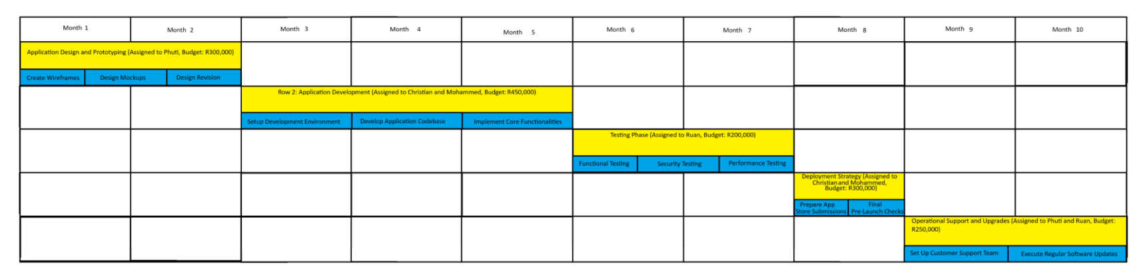

## Question 3.2:

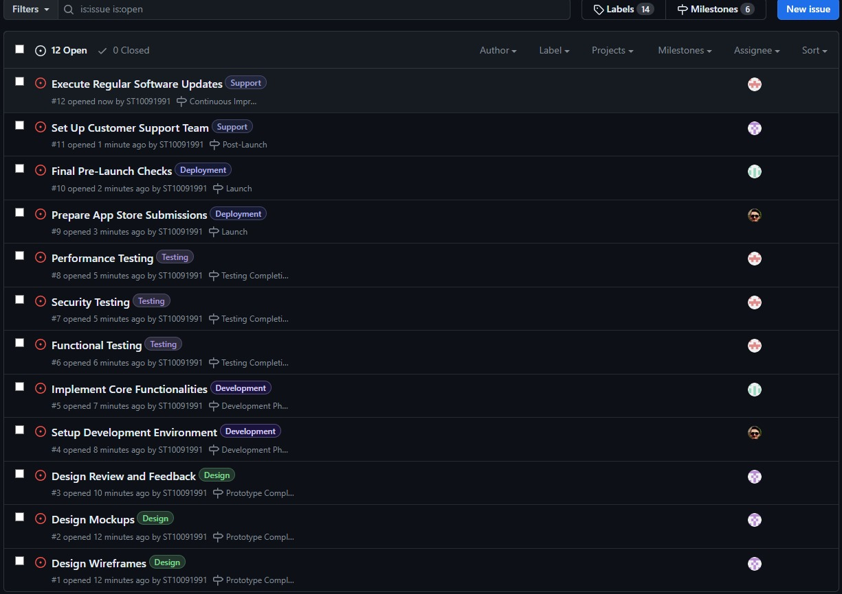  
link : <https://github.com/ST10091991/IPMAA2GroupE>

## Question 4.1:

## Question 4.2:

Getting the project done on time depends on a few main things like starting efficiently, how complex the design is, working on different parts at the same time, detailed testing, and careful planning for launch. It's important for the team to talk clearly and work together to avoid delays. They also need to be ready for sudden problems with good backup plans. The most important tasks, from initialisation, designing, developing, testing, deploying, to post deployment support, need close attention to finish on schedule. Good project handling, putting resources where they're needed, and keeping an eye on progress all the time are key to staying on track, being ready to change course as needed to overcome hurdles. (MindTools, 2024) Based off our network diagram, the project will definitely be completed before the deadline due to the efficient use of time, proper separation of duties and a progressive workflow. (MindTools, 2024

## Question 5.1:

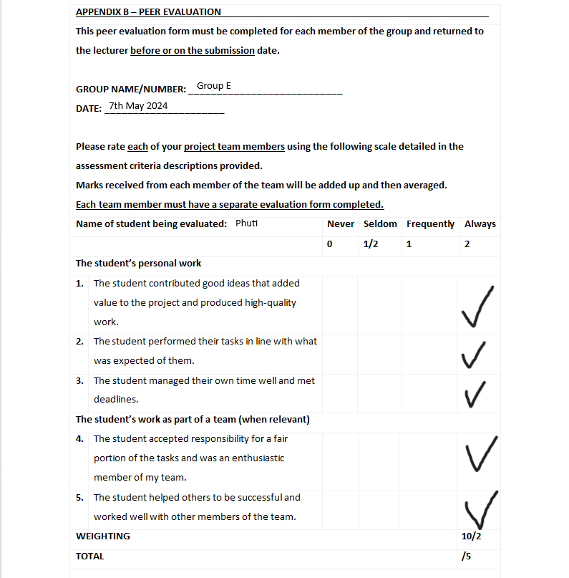

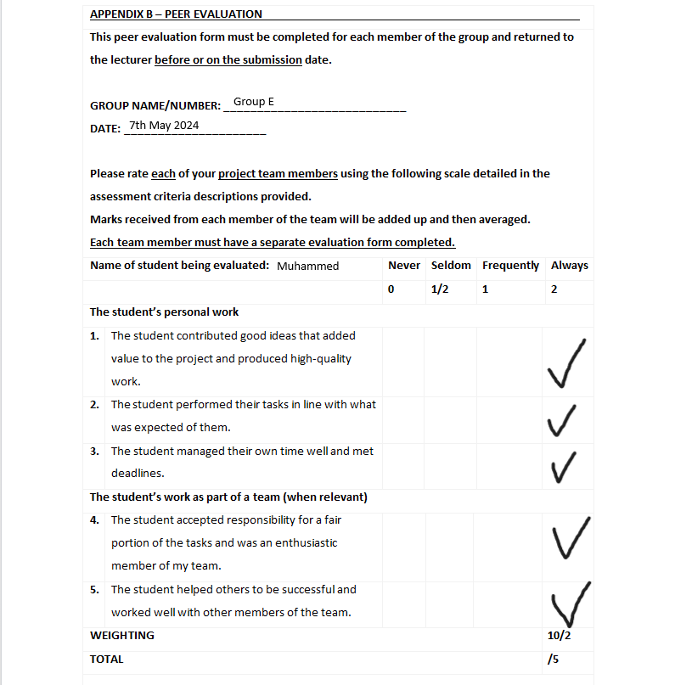

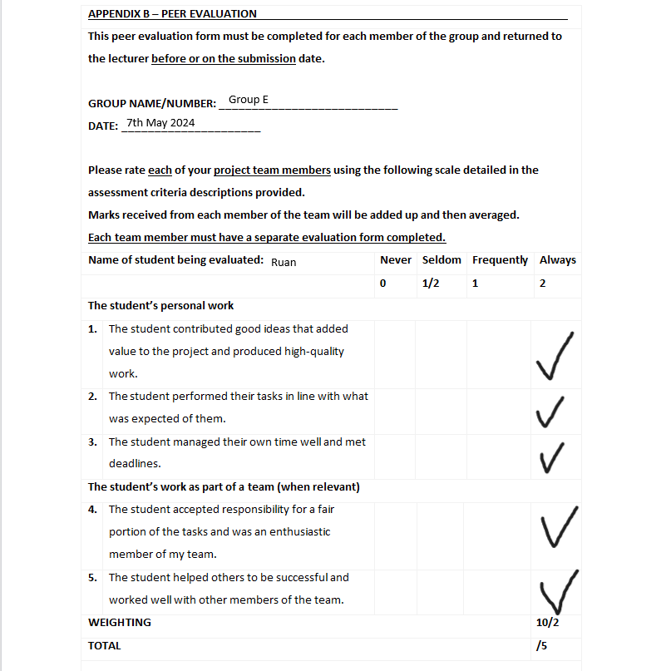

Question 5.2:

I will discuss a few topics that I enjoyed learning about, some topics that I didn't fully understand before the assignment, my role in the team, the skills I learned while working on the assignment, the research I had to do in order to complete the assignment, my relationship with my teammates, and the potential effects of this assignment on others in my self-reflection report.  
  
I now realize that conducting research is one of the most crucial steps to take before beginning any kind of work. You have a much better idea of what you should be doing and how to do it by conducting the study and learning more about the issue/situation. For example, I learned a lot about how technology should be designed, developed, and maintained, as well as about how many people feel, while I was researching an app that would allow users to report crimes anonymously.  
  
This was due to the fact that crimes can range from small-time offenses like pen theft to serious ones like murder. As a result, I gained a greater understanding of people's desire to avoid harm as well as how wary most people are of crime and similar situations. By saying this, I also gained a lot of knowledge about personal leadership and how to effectively handle problems that arise—not just in the context of the project, but also when individuals are unable to deliver because “Life happens.” This taught me how to handle these problems without having to alter the course of the project or allow a minor issue to become a major roadblock to further work.  
  
Since everyone in my group is friends outside of varsity, we don't mind doing a little extra work here and there if someone on the team is busy because we can always make it right another way outside of the assignment. As the group leader for the project, I assigned tasks and assisted anyone who needed help with their research.   
We all knew each other's personalities and how to handle different situations without getting into arguments or creating problems, which really aided in communication and the team's general culture.  
  
The majority of the research I conducted for this assignment consisted of visiting as many websites as I could and reading through the content on each one. With this, if a topic has agreement from more than 75% of the sites, I will take that as true since it can be independently verified by several sources. Along with using the assigned textbook, I also went to my mother, who works as a scrum master for an ABSA development team, to get extra explanation on a few topics.

Although I genuinely think that this app would be fantastic if it were to become a reality and probably reduce crime, there are a few other aspects that could make the app unsuccessful, such police response times and possibly even corruption. Although I think it would be a fantastic tool, I can't be positive that it would function as planned because of too many uncontrollable outside variables.   
In conclusion, my team's project was a success, and we had little to no problems organizing or carrying out any of the work. Once more, I think the app would be fantastic and I hope a lot of people could use it.

## Reference List:

(she/her), H.F. *et al.* (no date) *An intro to git and github for beginners (tutorial)*, *HubSpot Careers*. Available at: https://product.hubspot.com/blog/git-and-github-tutorial-for-beginners (Accessed: 03 May 2024).

Babich, N., About The AuthorNick Babich is a developer and Author, A.T. (2018) *A comprehensive guide to mobile app design*, *Smashing Magazine*. Available at: https://www.smashingmagazine.com/2018/02/comprehensive-guide-to-mobile-app-design/ (Accessed: 03 May 2024).

*Cross-platform development: Pros and Cons [updated list 2022]* (2022) *AppsChopper Blog*. Available at: https://www.appschopper.com/blog/pros-cons-cross-platform-mobile-app-development/ (Accessed: 03 May 2024).

Bi&oslash;rn-Hansen, A. *et al.* (2020) *An empirical investigation of performance overhead in cross-platform mobile development frameworks - empirical software engineering*, *SpringerLink*. Available at: https://link.springer.com/article/10.1007/s10664-020-09827-6 (Accessed: 03 May 2024).

Gillis, A.S. (2023) *What is a project charter? definition and examples*, *CIO*. Available at: https://www.techtarget.com/searchcio/definition/project-charter (Accessed: 03 May 2024).

*Infrastructure automation tools - chef infrastructure management: Chef* (no date) *Chef Software*. Available at: https://www.chef.io/products/chef-infrastructure-management?cq_src=google_ads&cq_cmp=21118669141&cq_term=configuration+management&cq_plac=&cq_net=g&cq_plt=gp&gclsrc=aw.ds&&utm_source=google&utm_medium=cpc&utm_campaign=chef-nb-at-en-EMEA&ad_group=configuration-management&utm_term=configuration%2Bmanagement&ad_copy=&ad_type=&ad_size=&ad_placement=&utm_content=chf-driver-security-and-compliance&gad_source=1&gclid=Cj0KCQjwltKxBhDMARIsAG8KnqV-1vIK4ognu5zrkv-jmrrZltdNdOsjTYUKsV87OgBROLp-n0B30WEaAgNMEALw_wcB (Accessed: 03 May 2024).

Ionicframework (2022) *What is cross-platform mobile application development?*, *Ionic*. Available at: https://ionic.io/resources/articles/what-is-cross-platform-app-development (Accessed: 03 May 2024).

Nowacka, A. (2024) *The Pros and cons of cross-platform app development*, *GMI Software*. Available at: https://www.gmihub.com/blog/cross-platform-app-development/ (Accessed: 03 May 2024).

*Pros & cons of cross-platform and Native Mobile App Development* (2023) *Merehead*. Available at: https://merehead.com/blog/cross-platform-native-mobile-app-development/ (Accessed: 03 May 2024).

*The Pros and cons of cross-platform app development* (no date) *Andersen*. Available at: https://andersenlab.com/blueprint/cross-platform-development-pros-and-cons (Accessed: 03 May 2024).

Team, Z. (2023) *Native vs hybrid mobile app development: Choosing the best approach (2023)*, *Zartis*. Available at: https://www.zartis.com/native-vs-hybrid-mobile-app-development/ (Accessed: 03 May 2024).

*What is a network diagram in project management?* (no date) *Versatile & Robust Project Management Software*. Available at: https://www.wrike.com/project-management-guide/faq/what-is-a-network-diagram-in-project-management/ (Accessed: 03 May 2024).

*Work breakdown structure* (no date) *workbreakdownstructure.com*. Available at: https://www.workbreakdownstructure.com/ (Accessed: 03 May 2024).

*Work breakdown structure (WBS): The Ultimate Guide (with examples)* (2024) *ProjectManager*. Available at: https://www.projectmanager.com/guides/work-breakdown-structure#:~:text=A%20work%20breakdown%20structure%20(WBS)%20is%20a%20visual%2C%20hierarchical,required%20to%20complete%20their%20projects. (Accessed: 03 May 2024).

MindTools, 2024. MindTools. [Online] Available at: https://www.mindtools.com/a8im0bj/how-to-meet-a-deadline [Accessed 20 APRIL 2024]. Sebastian, 2024. Project management info. [Online] Available at: https://project-management.info/project-schedule-network-diagram/ [Accessed 17 April 2024]. Sundesh, D., 2024. Create Network Diagrams (CH4). Midrand: s.n.